Bharath yalagi
Bharathyalagi29738@gmail.com
Mini Project-3
Bharath Yalagi

- Token Generation

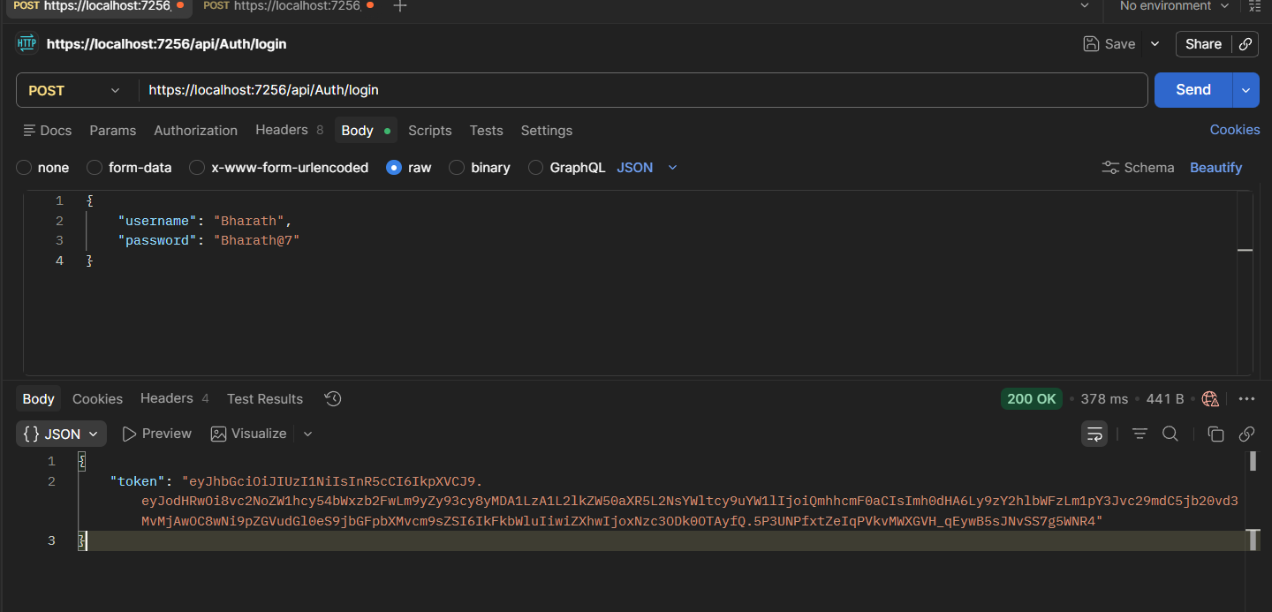

- Token add (Authorization)

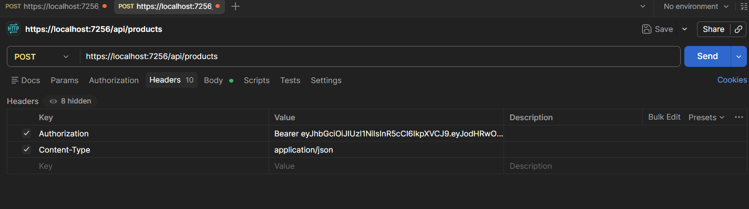

- Post Products
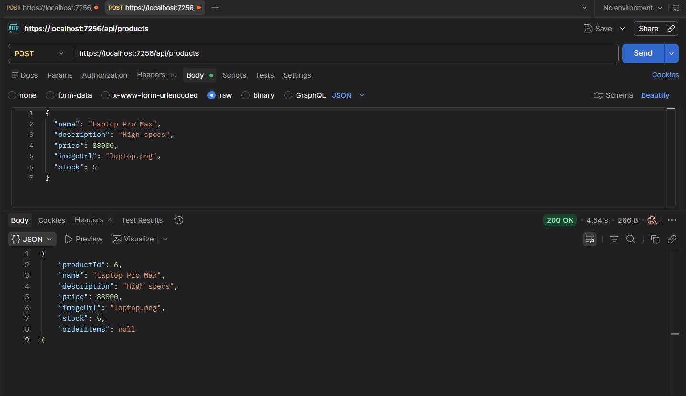

- Get Products
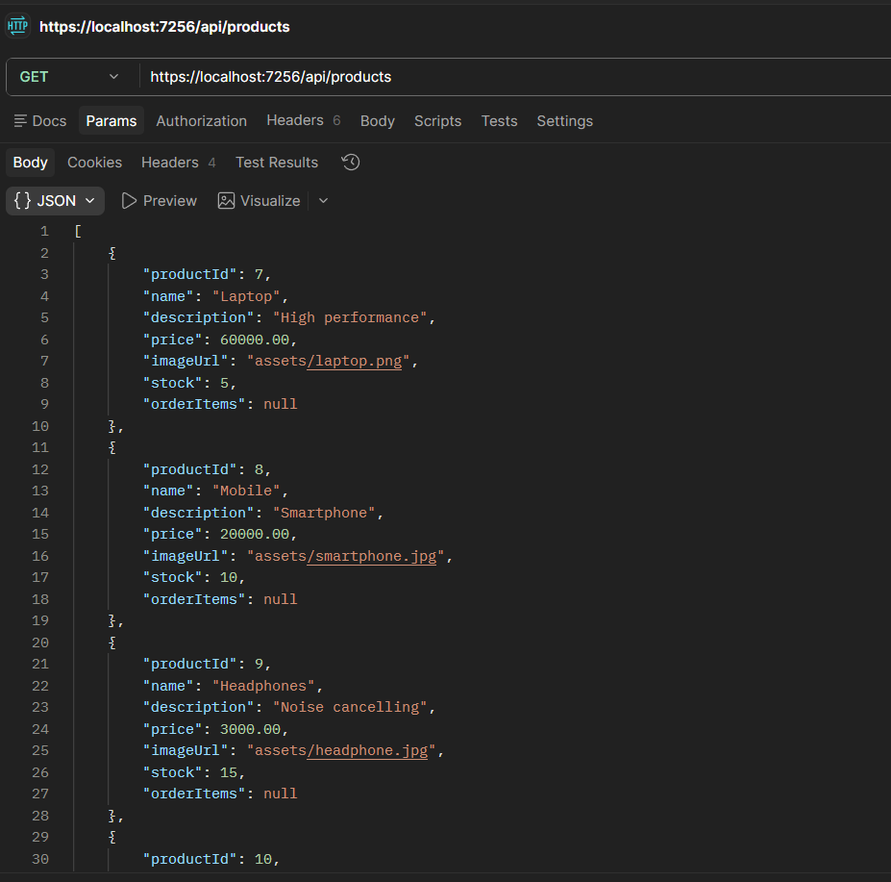

- UNIT Testing (ng test)

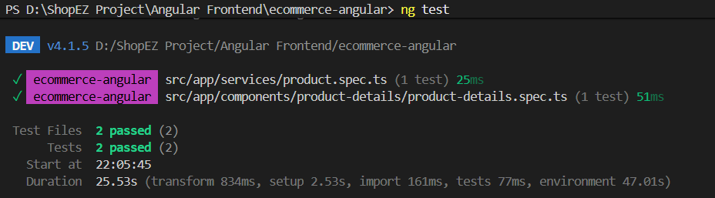

Summary:
To ensure the reliability and security of the ShopEasy backend, comprehensive testing was conducted throughout the development cycle. This includes API authentication validation via Postman, where token generation was verified to authorize protected endpoints, alongside CRUD operations for product management ('Get' and 'Post' requests). Furthermore, frontend integrity was validated unit tests (ng test) to ensure component-level stability. For a detailed walkthrough of these functional flows and test executions, please refer to the video demonstration included in the /testing directory of the project repository.

